**Intro to AWS Lambda**

Time spent: 30min

Overview:

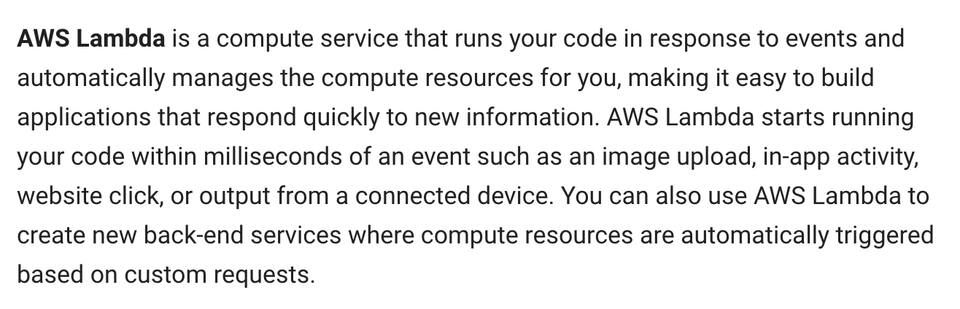

Application Structure

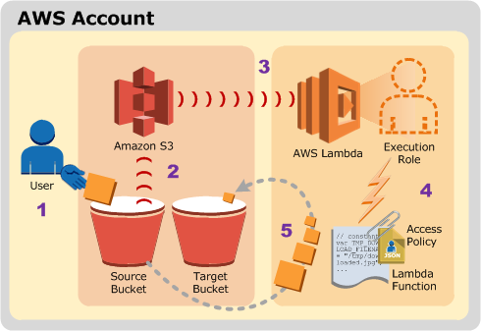

**What I learned:**

* How to build the Lambda function
* How to add the trigger to the function
* How to test a Lambda function

**What I built:**

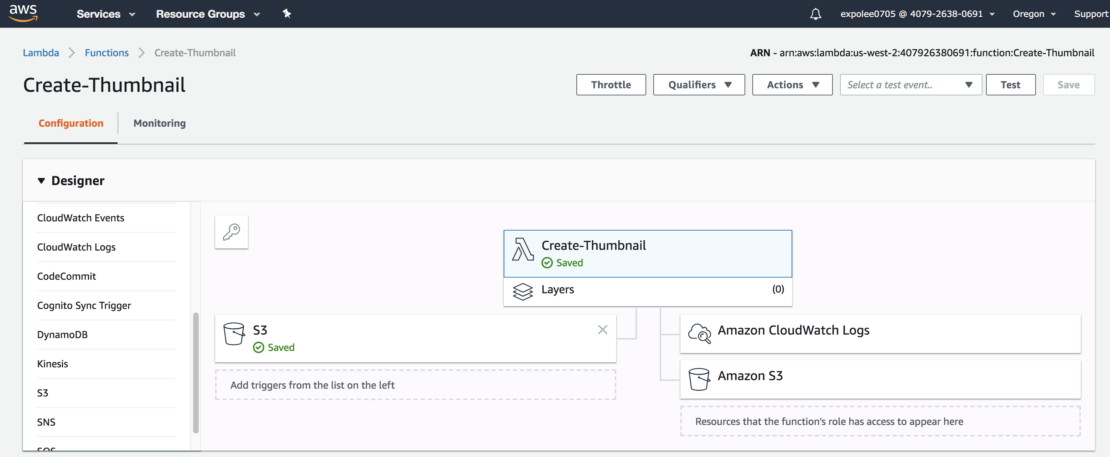

* **Test the function**

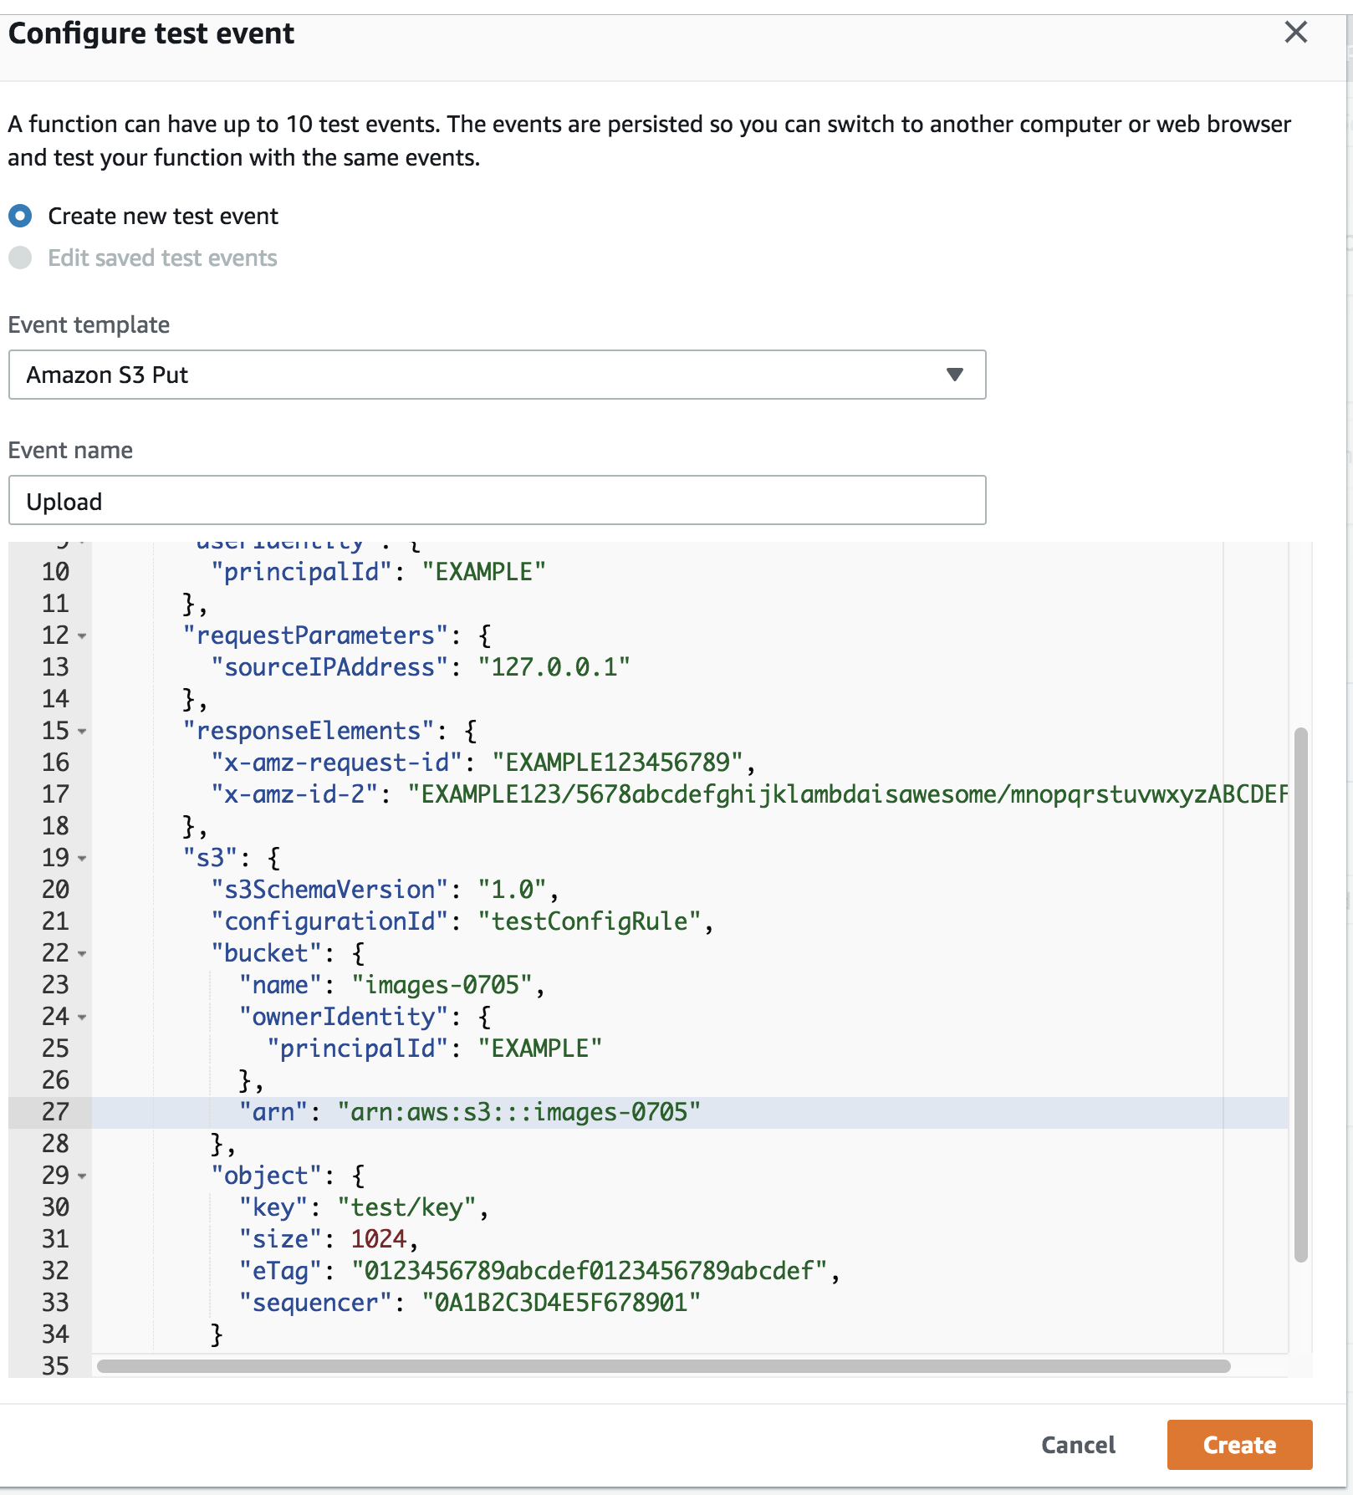

* **Function work and get the resized picture**

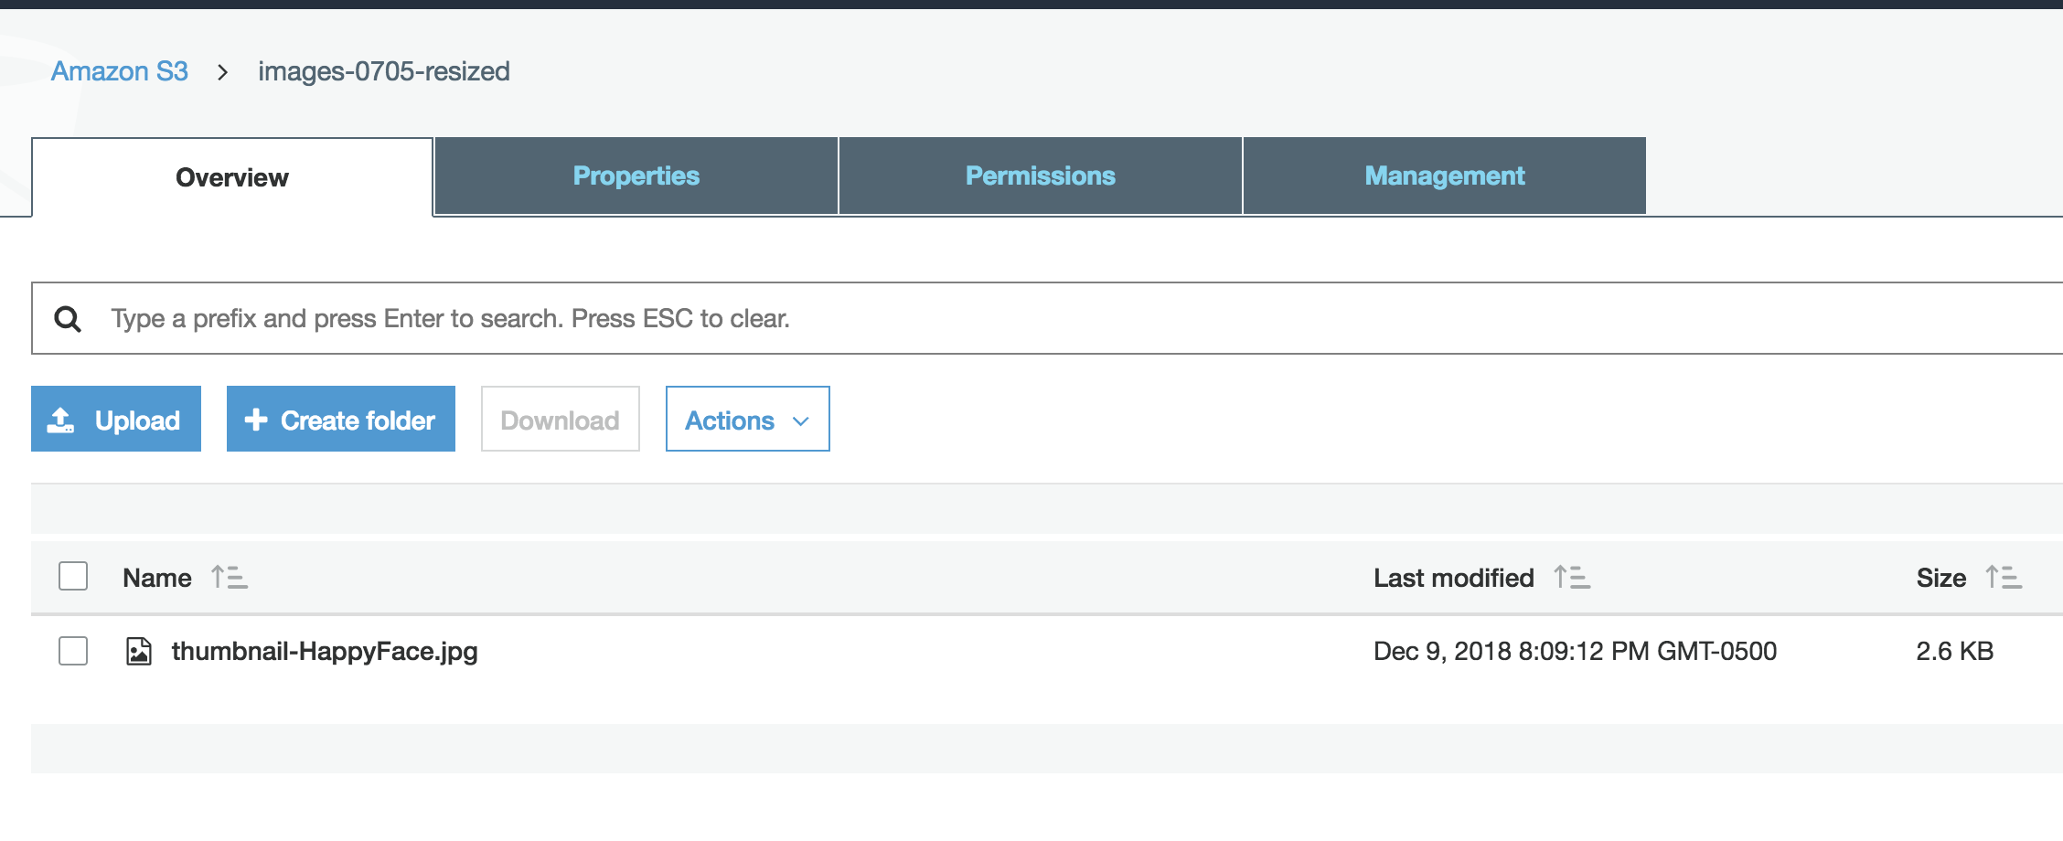

**Summary:**

In this section, I learned how to use Amazon Lambda which plays a role like a programmable event flow.